**Phase 7: Integration & External Access**

**Named Credentials:**

Named Credentials securely store authentication and endpoint information for external APIs, simplifying callouts.

**Configuration:**

* **Name:** ShippingAPI
* **URL:** https://api.shipping.com
* **Identity Type:** Named Principal
* **Authentication Protocol:** Basic Authentication
* **Scope:** read write

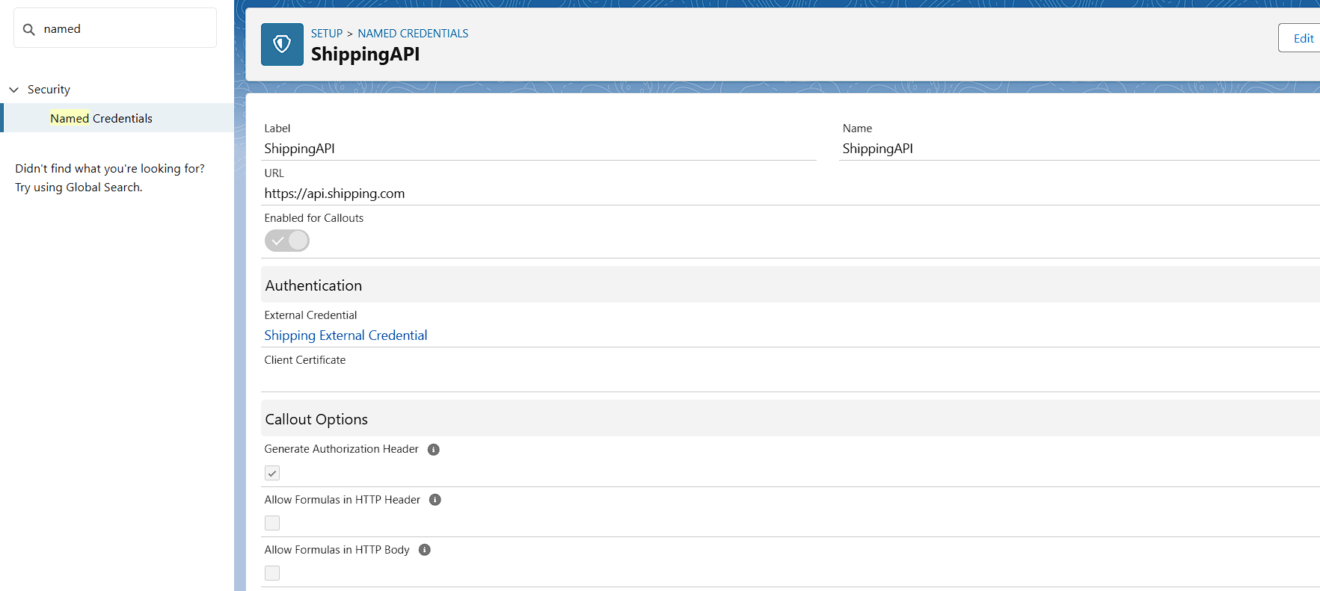

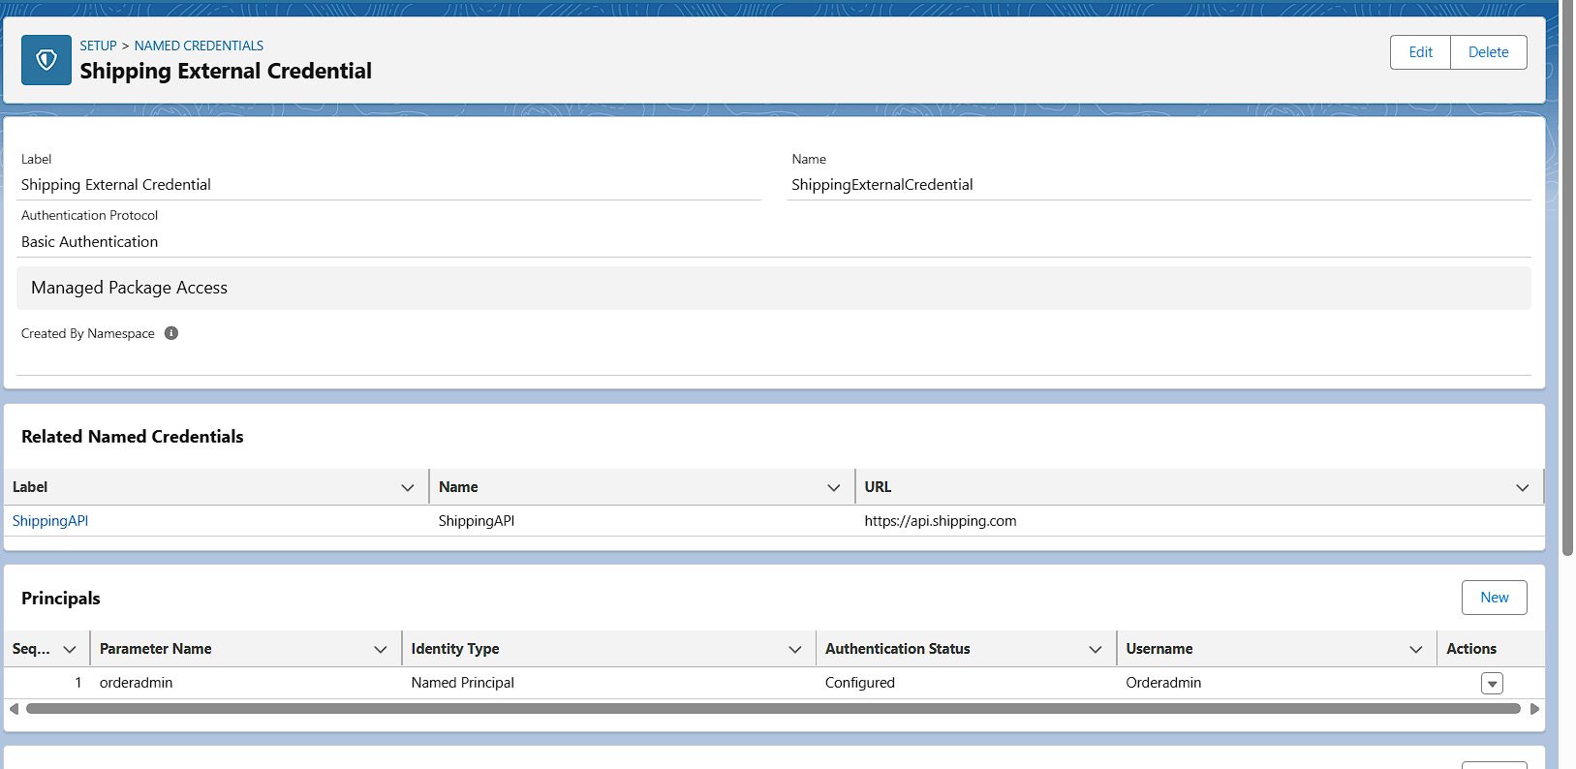

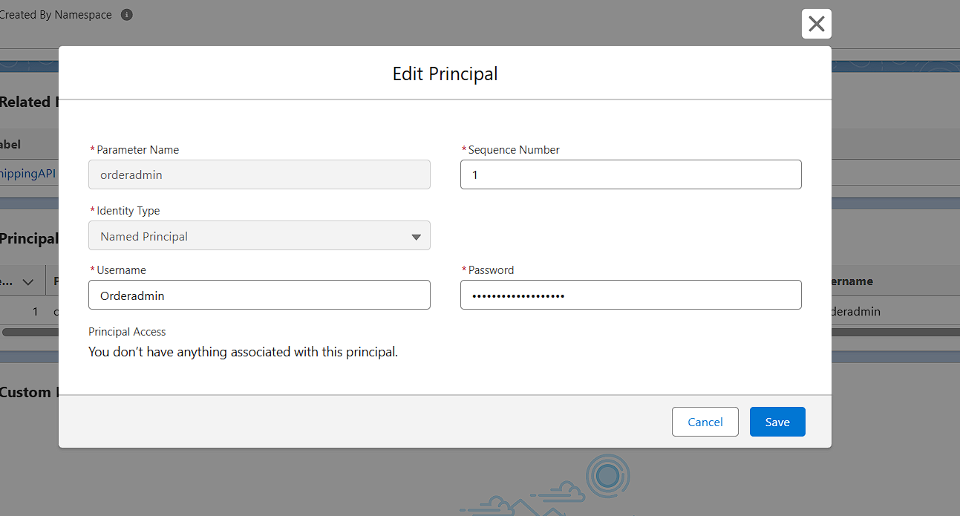

**External Services:**

**Definition:** Declarative integration of REST APIs using OpenAPI (Swagger).

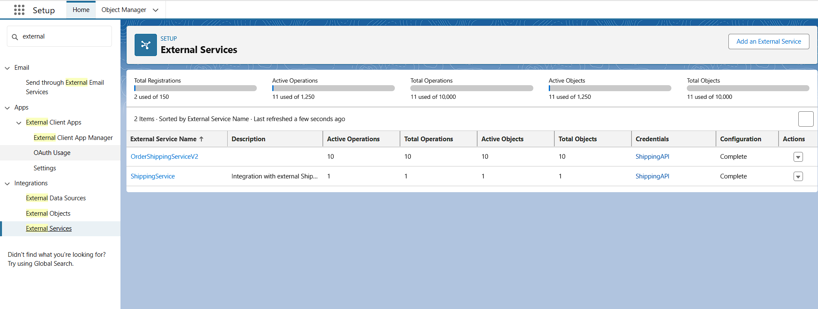

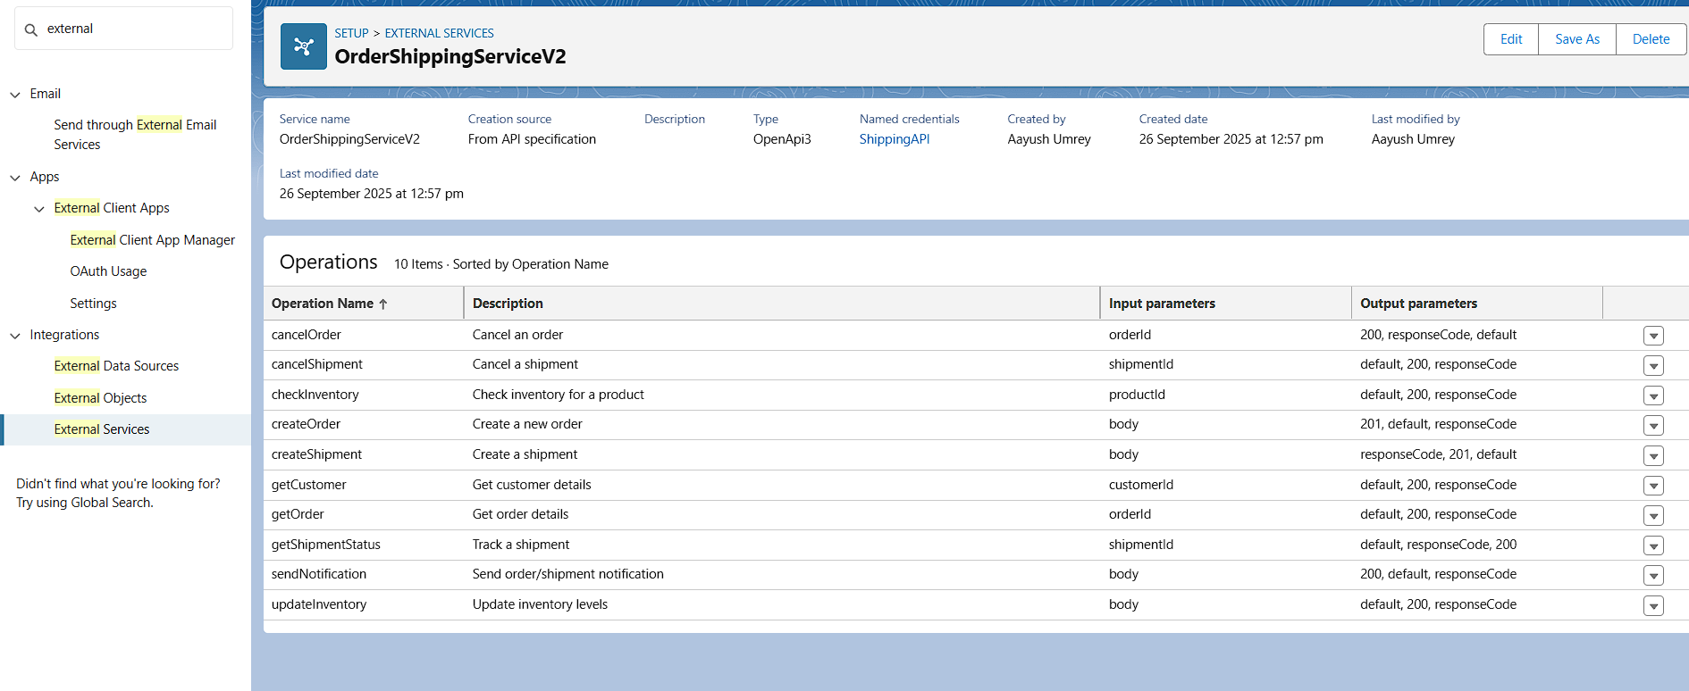

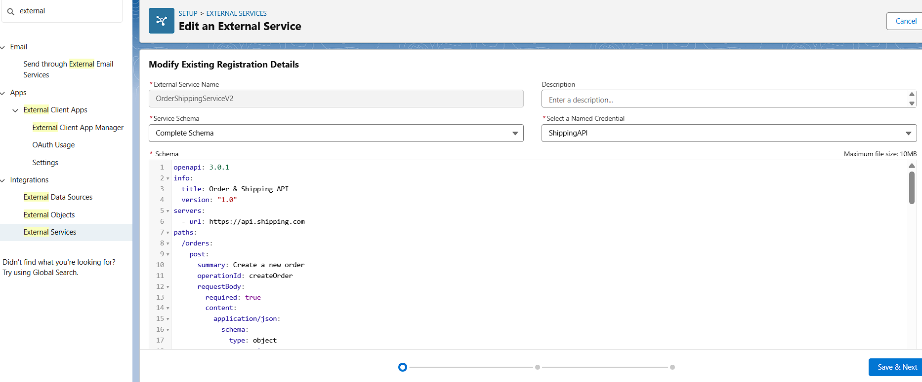

**Web Services (REST/SOAP):**

**Description:**  
Salesforce can expose its own APIs to external systems or call external APIs using REST or SOAP protocols.

* **Apex Class:** OrderRestAPI
* **URL Mapping:** urlMapping='/orders/*'
* **HTTP Methods:** @HttpGet, @HttpPost

**Logic:** Handles order retrieval and creation using Apex

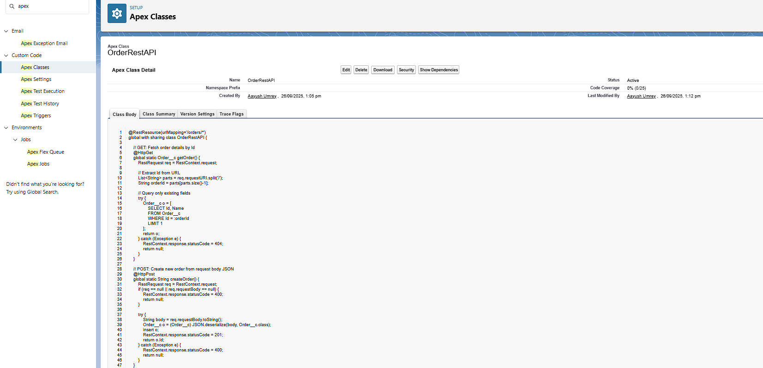

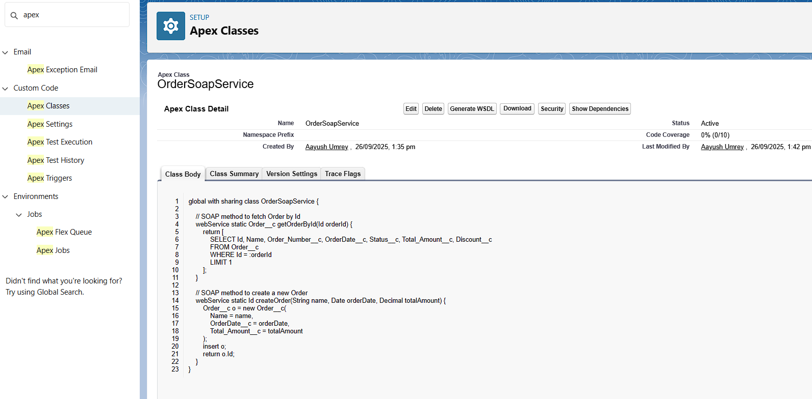

**Callouts:**

Description: Apex or Flow callouts enable Salesforce to send or receive data from external APIs.

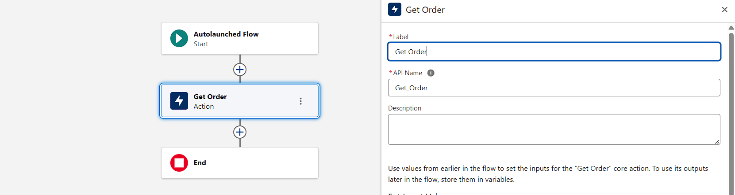

**Platform Events:**

**Description:** Platform Events facilitate real-time communication between Salesforce and external systems.

**Configuration:**

* **Event Name:** OrderEvent__e
* **Fields:**
  + OrderId__c
  + Status__c
  + TotalAmount__c
* **Trigger:** OrderEventTrigger

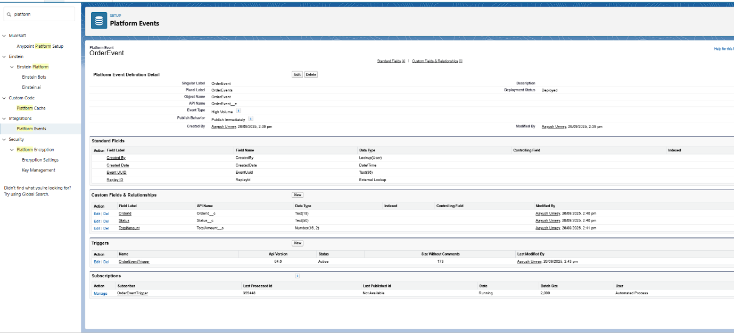

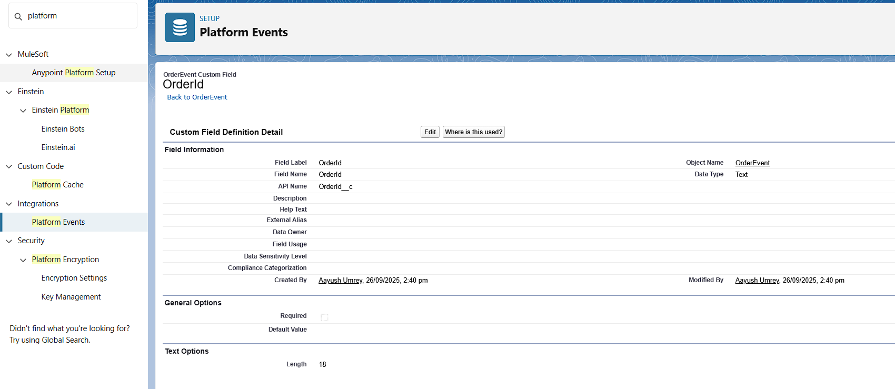

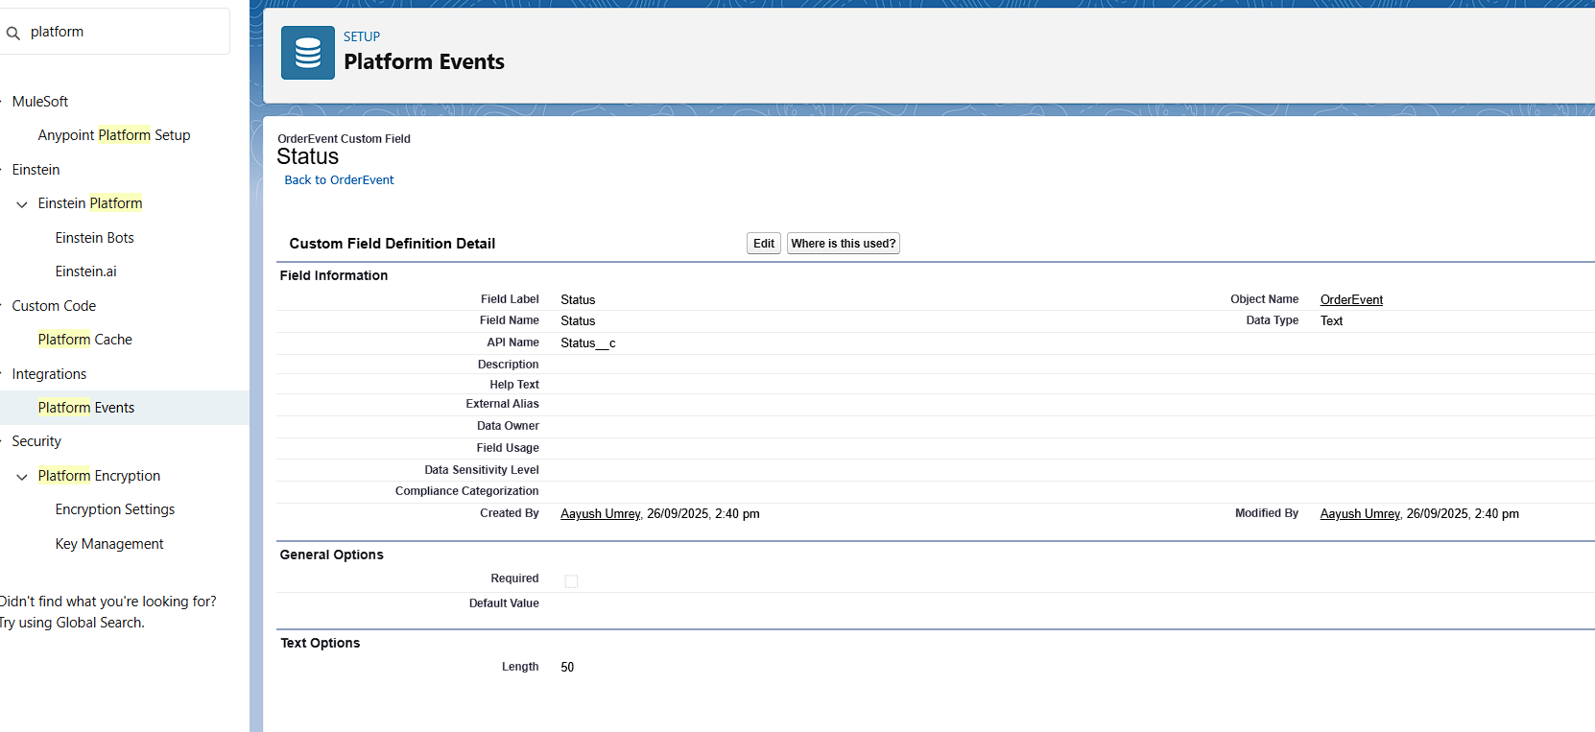

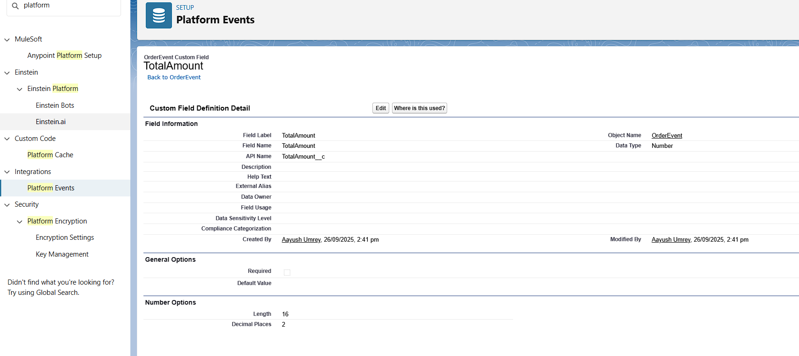

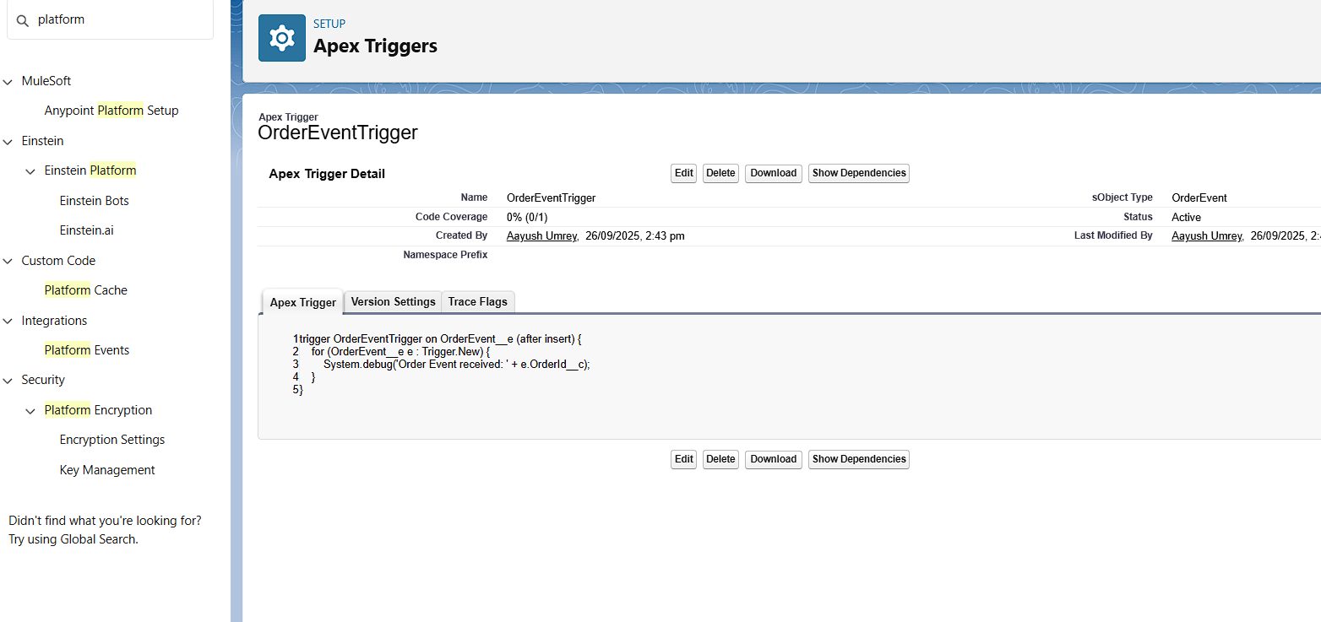

**Change Data Capture:**

**Description:** Change Data Capture (CDC) allows Salesforce to capture changes in records and notify external systems.

**Configuration:**

* **Enabled Objects:** Order__c, Product__c,User
* **Trigger:** OrderChangeCaptureTrigger

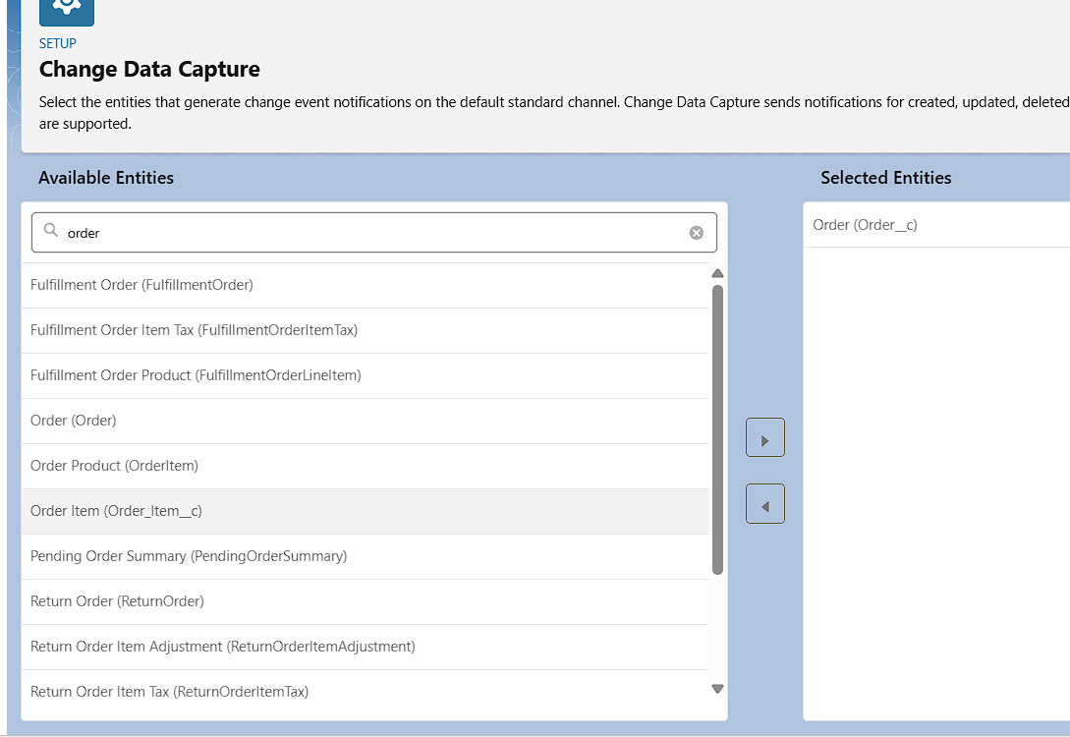

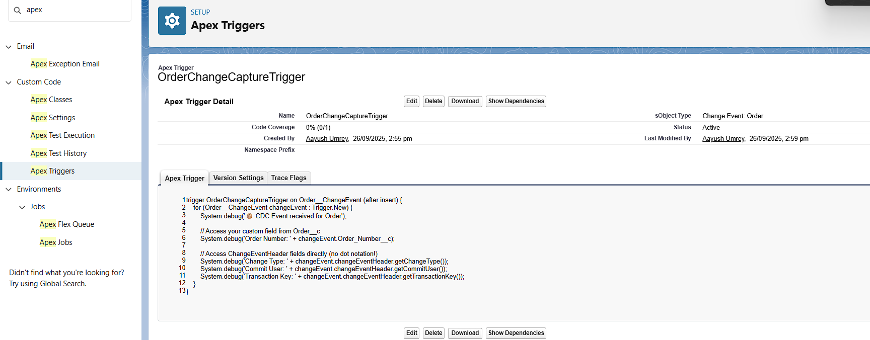

**Salesforce Connect:**

**Description:** Salesforce Connect enables Salesforce to access and display data from external systems in real-time.

* **External Data Source:**
  + **Name:** ExternalInventory
  + **Type:** Salesforce Connect: OData 2.0
  + **Endpoint URL:** [**https://api.Orderly.com/**](https://api.Orderly.com/)
  + **Identity Type:** Anonymous
  + **Authentication Protocol:** No Authentication

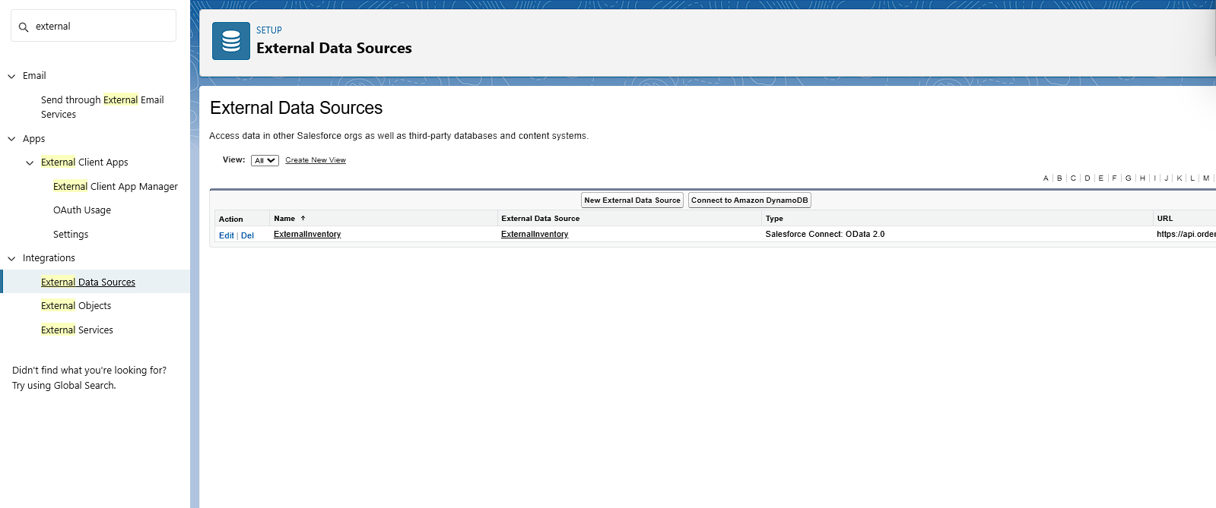

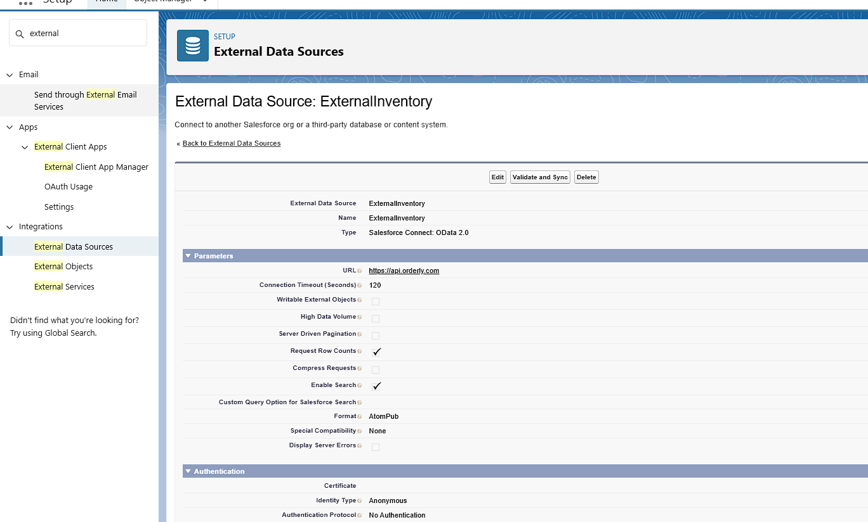

**API Limits:**

**Description:** Salesforce imposes limits on API usage to ensure fair resource allocation and system stability.

**Configuration:**

* **API Limit Monitoring:** Regularly monitor API usage through the System Overview page.
* **Optimization:** Implement efficient coding practices to minimize API calls.

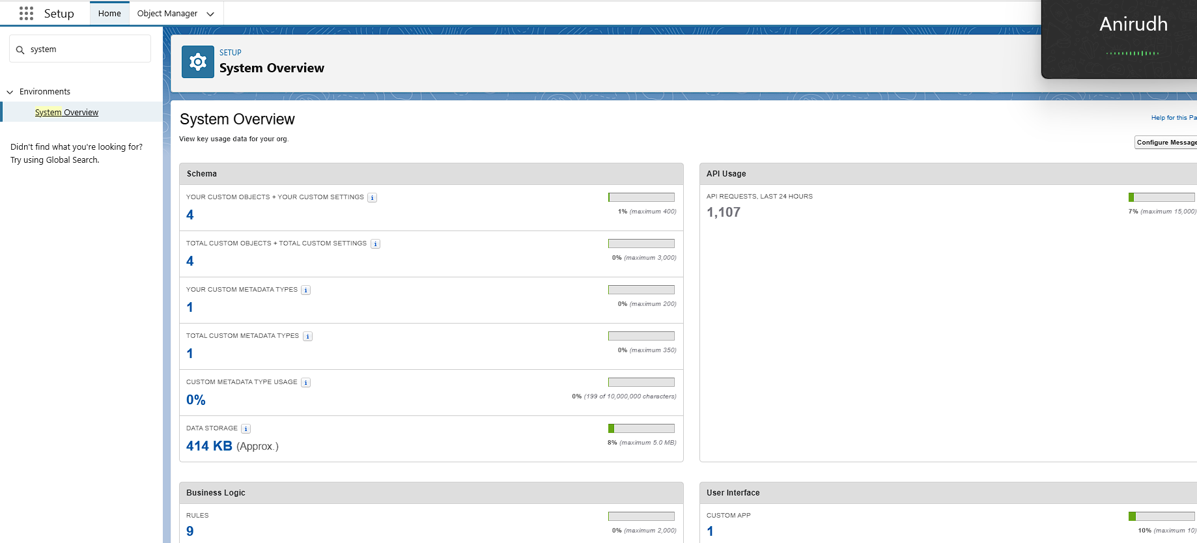

**OAuth & Authentication:**

**Description:**  
 OAuth 2.0 is used to authenticate and authorize third-party applications to access Salesforce data.

**Configuration:**

* Named Credentials cover authentication for external callouts.
* No extra action needed.

**Remote Site Setting:**

**Description**: Remote Site Settings define a list of external sites that Salesforce can communicate with.

**Configuration:**

* **Remote Site Name:** OrderlyAPI
* **Remote Site URL:** https://api.orderly.com
* **Active:** Checked

**Configuration:**

* **Remote Site Name:** Shipping_API
* **Remote Site URL:** <https://shipping-api-demo.com>
* **Active:** Checked

